Student Name:

Website Title:

HTML Tags
Feature | Yes | No | Page Reference
Format Text (H1, H2, p) | ☑ |  | <h3 class="blood-metallic-text">Rick Owens</h3><span id="main_desc"><p>Archive fashion ...  together.</p></span>
Format Text (inline) | ☑ |  | <u>$3500</u>  <strong>Vintage Aesthetic</strong>
Insert Graphic (img) | ☑ |  | <img src="images/vintage.png" class="img-fluid rounded" alt="Vintage Aesthetic">
Page Layout (div, header, section, aside, footer etc) | ☑ |  | 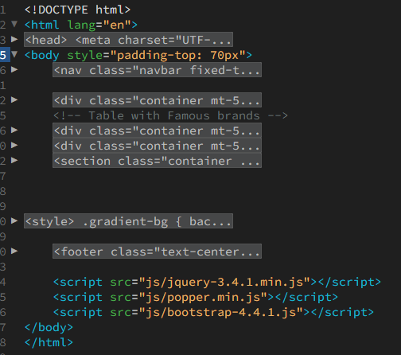
Navigation System | ☑ |  | 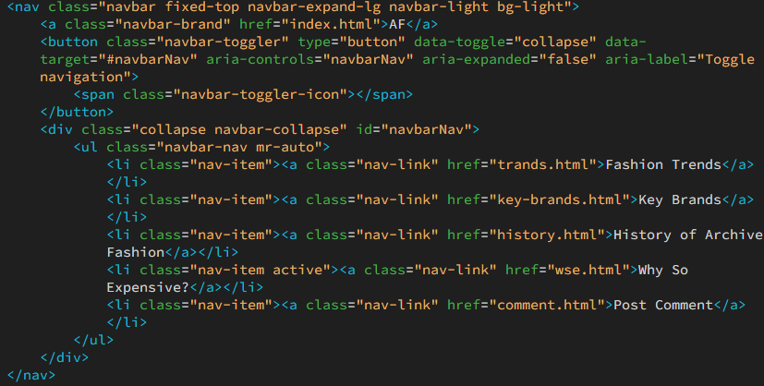
Internal Link | ☑ |  | class="nav-link" href="history.html"
External Link | ☑ |  | <a href="https://instagram.com" target="_blank" class="social-icon">
E-Mail Link | ☑ |  | <a href="mailto:artamonsav@gmail.com" class="social-icon">
Target Link | ☑ |  | <a href="https://linkedin.com" target="_blank" class="social-icon">
ID (Internal Page) Link | ☑ |  | <h2 style="text-align: center"><a href="#music">♪ Music ♪</a></h2>
Image Maps | ☑ |  | <img src="images/oversize.png" class="img-fluid rounded" usemap="#oversize-map" alt="Oversized Silhouettes">  <map name="oversize-map">  <area target="_blank" alt="Vetements 16XL Hoodie" title="Vetements 16XL Hoodie" coords="57,86,523,397" shape="rect">  <area  target="_blank"  alt="Jeans"  title="Vetements Blue printed jeans"  href="https://www.mytheresa.com/at/en/women/vetements-printed-low-rise-wide-leg-jeans-blue-p00827143"  coords="141,404,425,635"  shape="rect">  </map>  <img src="images/cyclinic.png" class="img-fluid rounded" usemap="#c-map" width="100%" alt="Fashion Cyclicity">  <map name="c-map">  <area target="_blank" alt="Jaded London" title="Jaded London" href="https://jadedldn.com/en-ie?srsltid=AfmBOooWXwW-xC_eXwOcoGuBh_8UCZUVD0mvik9NMtwLUi60gcDHn25Z" coords="340,818,1561,2756" shape="rect">  </map>
Ordered List | ☑ |  | <ol>  <li>Raf Simons</li>  <li>Martin Margiela</li>  <li>Hedi Slimane</li>  </ol></div>
Unordered List | ☑ |  | <ul class="navbar-nav mr-auto">  <li class="nav-item"> <a class="nav-link" href="index.html">AF<span class="sr-only">(current)</span></a> </li>  <li class="nav-item"><a class="nav-link" href="trands.html">Fashion Trends</a></li>  <li class="nav-item"><a class="nav-link" href="key-brands.html">Key Brands</a></li>  <li class="nav-item"><a class="nav-link" href="history.html">History of Archive Fashion</a></li>  <li class="nav-item active"><a class="nav-link" href="wse.html">Why So Expensive?</a></li>  <li class="nav-item"><a class="nav-link" href="comment.html">Post Comment</a></li>  </ul>
Definition Lists | ☑ |  | <dl class="text-center">  <dt>Archive Fashion</dt>  <dd>Fashion items from past seasons that are considered valuable due to their rarity, quality, or cultural significance.</dd>  <dt>Minimalism</dt>  <dd>A style that emphasizes simplicity, clean lines, and functionality, often using neutral colors and minimal embellishment.</dd>  <dt>Streetwear</dt>  <dd>A fashion style rooted in urban culture, often featuring casual clothing such as hoodies, sneakers, and graphic t-shirts.</dd>  </dl>
Form | ☑ |  | 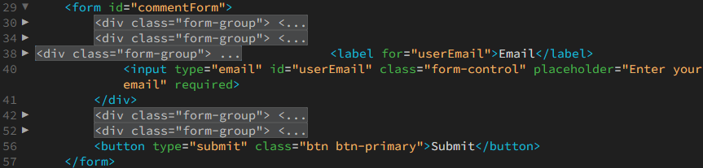
Tables | ☑ |  | 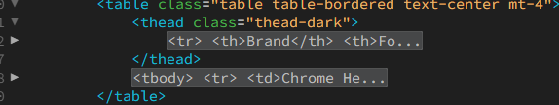
Comment Tags | ☑ |  | 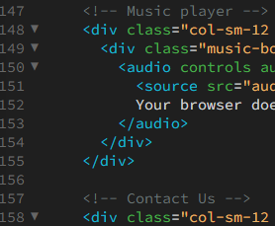
Meta Tags | ☑ |  | <meta charset="UTF-8" />  <meta http-equiv="X-UA-Compatible" content="IE=edge">  <meta name="viewport" content="width=device-width, initial-scale=1.0">
Multimedia (sound & video) | ☑ |  | <video class="video-container" controls poster="images/ERD.jpg">  <source src="videos/ERD-vid.mp4" type="video/mp4">  </video>  <audio controls autoplay>  <source src="audiO/Aphex_Twin_–_Xtal.mp3" type="audio/mp3">  Your browser does not support the audio element.  </audio>
HTML Special Characters | ☑ |  | <p>&copy; 2024 Archive Fashion. All rights reserved.</p>
Suitable colour palette applied | ☑ |  | 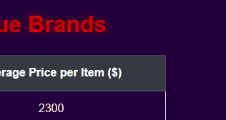
Use RGB & Hex colours | ☑ |  | 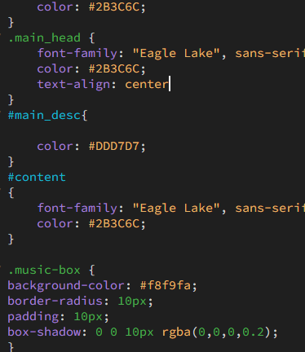

CSS Rules
CSS Rule | Yes | No | Page Reference
External Stylesheet | ☑ |  | <link href="css/styles.css" rel="stylesheet">
Internal Stylesheet | ☑ |  | 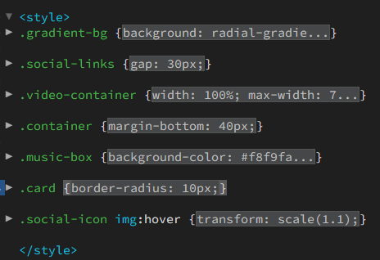
Inline Style | ☑ |  | <h2 id="main_head" style="text-align: center">  <ul style="list-style-type:square">
font-family | ☑ |  | font-family: "Eagle Lake", sans-serif;
font-style | ☑ |  | font-style: oblique;
font-variant | ☑ |  | font-variant: small-caps;
font-weight | ☑ |  | font-weight: bold;
Pseudo-elements: a:link, a:hover, a:active, a:visited | ☑ |  | 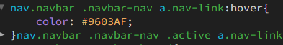
text-decoration | ☑ |  | text-decoration: underline;
text-align | ☑ |  | text-align: left;  style="text-align: center"
line-height | ☑ |  | line-height: 1.6;
color (Hex and RGB) | ☑ |  | rgba(5, 10, 20, 1) 8%,  rgba(20, 5, 35, 1) 18%,  rgba(30, 15, 60, 1) 35%,  rgba(20, 10, 25, 1) 50%,  rgba(10, 5, 10, 1) 80%,  rgba(0, 0, 0, 1) 100%  color: #2B3C6C;
background-color | ☑ |  | background-color: #343a40;
background-image | ☑ |  | background-image: url("data:image/svg+xml;charset=utf8,%3Csvg xmlns='http://www.w3.org/2000/svg' viewBox='0 0 30 30'%3E%3Cpath stroke='%23FFFFFF' stroke-width='3.26' d='M4 7h22M4 15h22M4 23h22' /%3E%3C/svg%3E") !important;
background-url | ☑ |  | background-image: url("data:image/svg+xml;charset=utf8,%3Csvg xmlns='http://www.w3.org/2000/svg' viewBox='0 0 30 30'%3E%3Cpath stroke='%23FFFFFF' stroke-width='3.26' d='M4 7h22M4 15h22M4 23h22' /%3E%3C/svg%3E") !important;
Position: absolute, relative, static, fixed, float |  | ☑
CSS Rule | Yes | No | Page Reference
border | ☑ |  | border-bottom: 4px solid #412840;  border-right: 1px solid #999;
list-style-type | ☑ |  | <ul style="list-style-type:square">
list-style-image
Units: %, ems, small, medium, large | ☑ |  | margin-top: 50px;  0% { background-position: 0% 50%; }  opacity: 0.9;  font-size: 1rem;
Comment Code | ☑ |  | <!-- Contact Us form -->  /* Gradient background */  /* Animated blood-metallic text */

Website Report
Feature | Page
Aims and Objectives | 1
Identify target audience | 1
Site Map | 3
Web Page Sketches / Notes
Describe the navigation solution for your web site
Software Review | 4
Developments in HTML / CSS
Validate HTML / CSS with W3C
Responsive testing
Test web page download (access) speeds
Evaluation and recommendations
Hardware / Software Specification | 4
Research

